Calculate Pay with Overtime

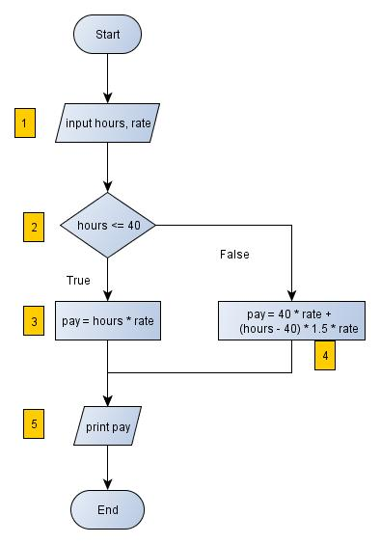

**Pseudo Code**

Begin

Input hours, rate

If hours <= 40 then

pay = hours * rate

Else

pay = 40 * rate + (hours – 40) * rate * 1.5

Print pay

End